**Clinic Prepper v1.0  
ReadMe: 12/06/24**

**Note contains sensitive information – do not share outside of trust computers.**

Please find contained instructions and output of Clinic Prepper version v1.0

**Program Setup and Usage**A Python compiler is required to run this program. Contact IT to allow installation of Python 3.12.2.  
I can direct installation from there.

A folder containing the “clinic prepper” program will be copied into your own documents directory.

It doesn’t matter where in your documents this folder goes, however it will need to contain 2 special directories as illustrated below:

The two folders called “clinic lists” and “prepped clinics” are special and will be where the program does its magic.

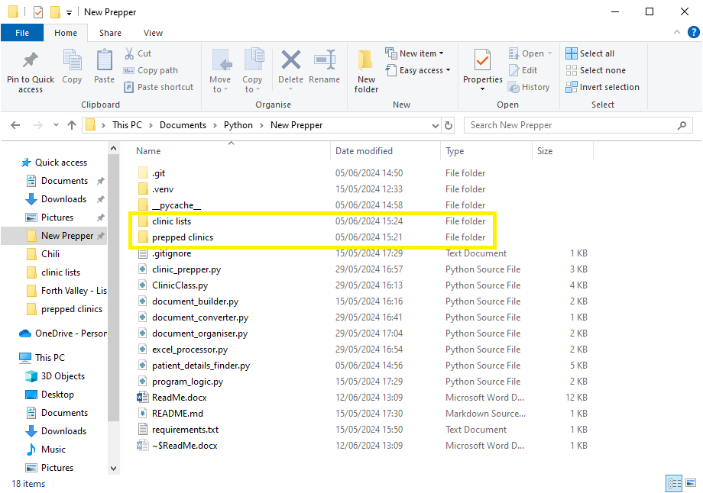

These folders contain the information the program uses to build clinic prep.

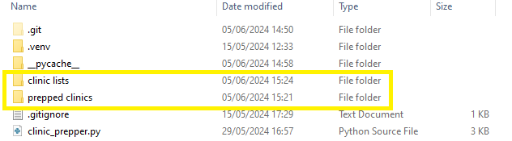

**Clinic information gathering Process:**

From within the “clinic lists” folder you will see a file called - “Template Clinic Captures.xls”

Open this and you will see a blank form as below:

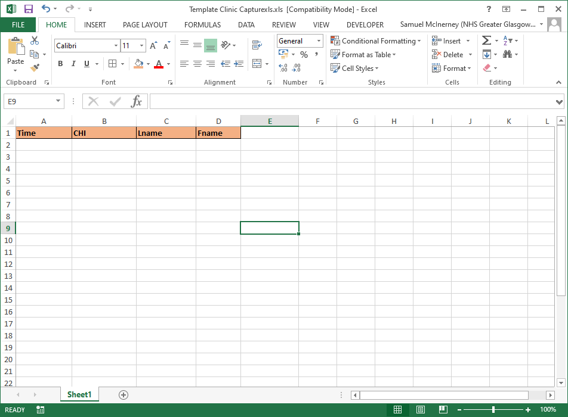

Then go to your desired clinic and copy only the Time, CHI Surname and Patient Name fields in a single line as below:

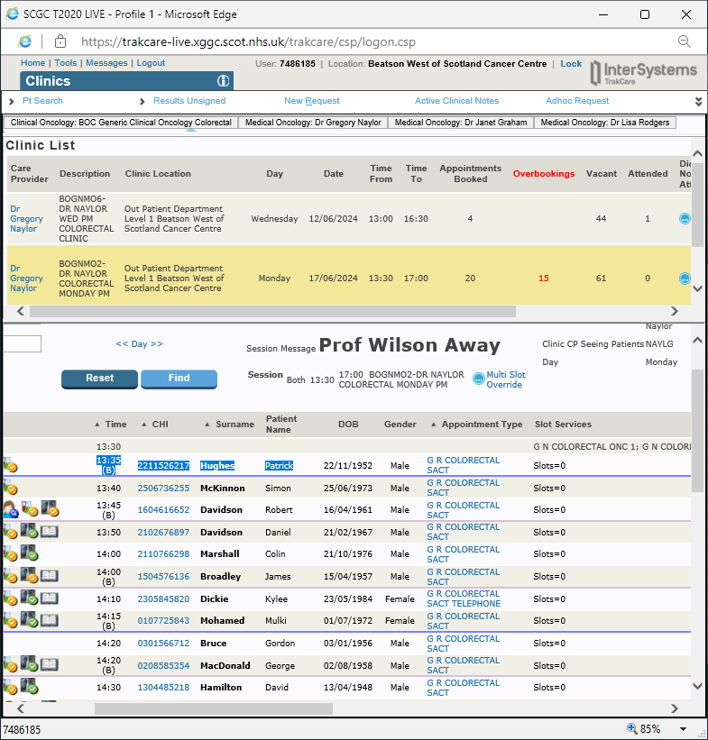

This can then be pasted directly into the template.

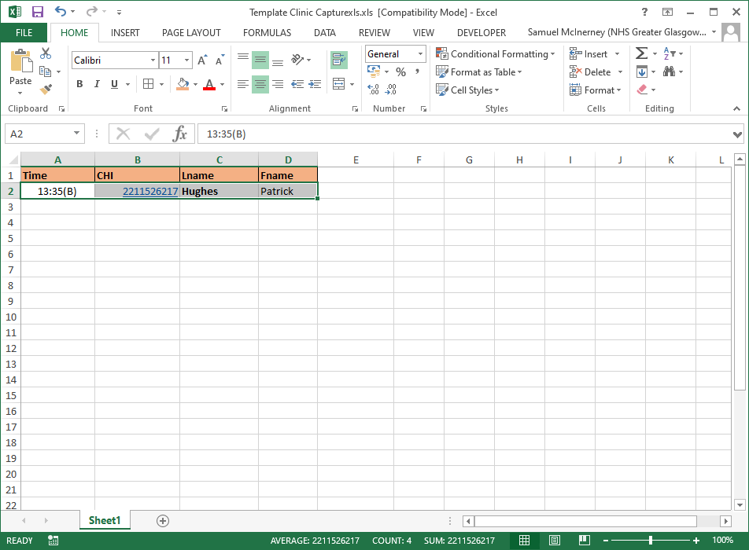

Do this for each patient in the clinic. Note – it’s important to only copy these 4 fields individually and not try and copy the whole group in 1 go – this takes lots of additional information and images out of TRAK and will stop the program working.  
  
This process should take no more than 2 or 3 minutes and you will be left with a sheet that appears as below:

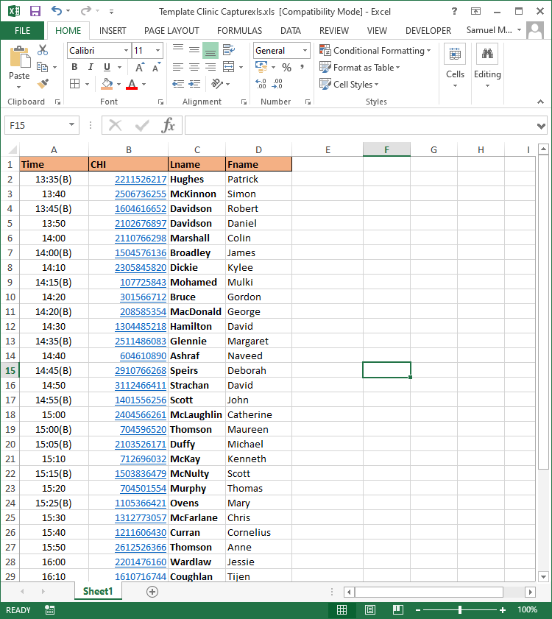

Save this file as appropriate – for example “GN Clinic 170624” Then you need to run the program.

**Running the Program:**

When running the program you will see a dialog box as below:

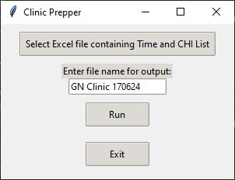

The “Enter file name for output” is pre-populated with the next Monday and the format “GN Clinic DDMMYY” – you should not need to change this but can do so if you wish.

The top button “Select Excel file…” should be pushed.

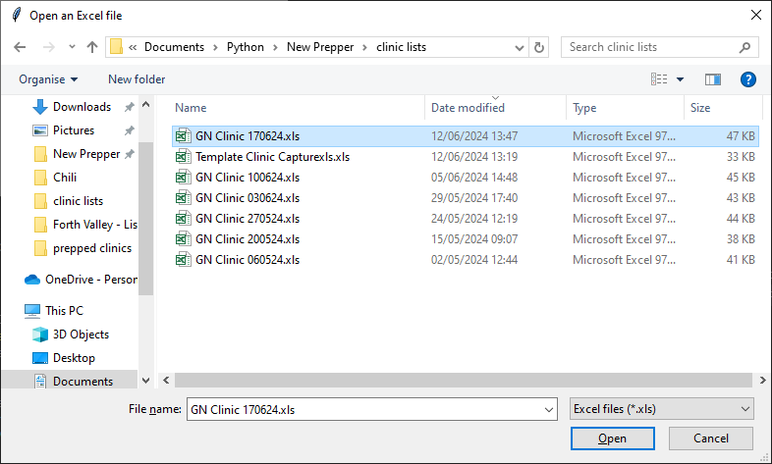

You can then direct the program to your freshly made clinic list as above.

Then click “Run”.

After a few moments you will see a dialogue box appear:

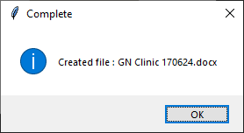

If you then navigate to the “Prepped clinics“ folder you will see the generated file:

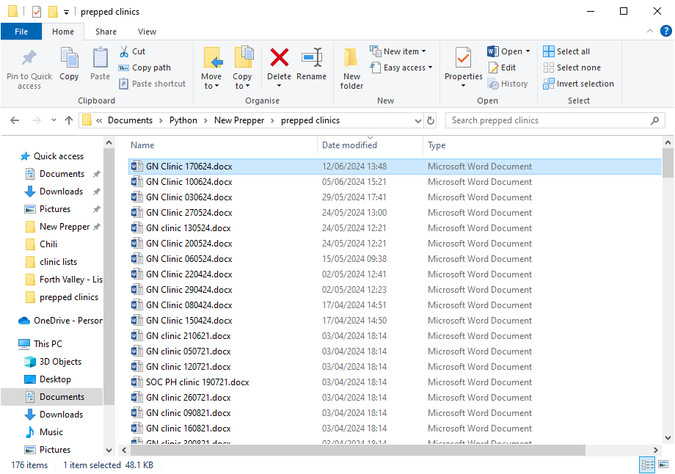

The generated document is made from the information stored in the “prepped clinics” folder.

It is matched by CHI number – so if there is no previous letter or entry in the folder – it will respond with “None Found”.

If a previous entry is found, it will take the most recent entry and display the text associated with the CHI.

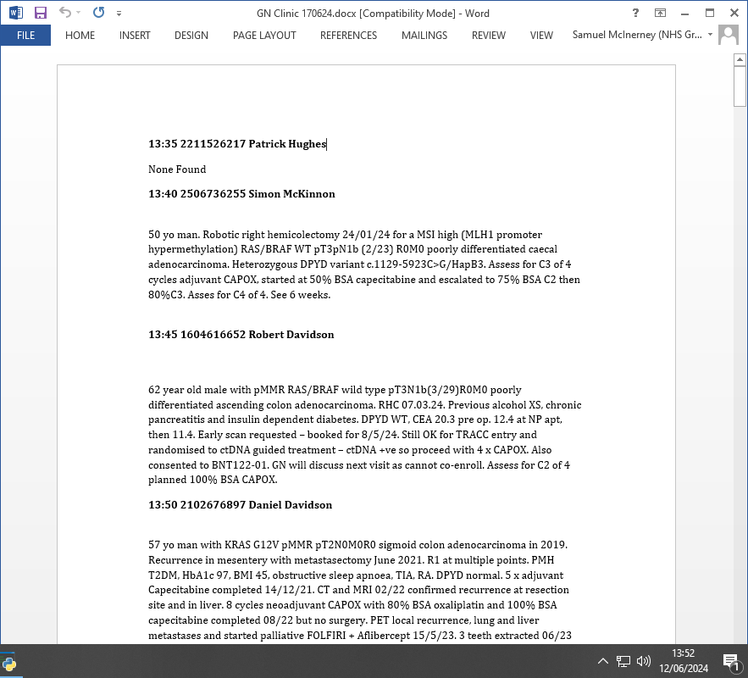

**Ongoing Work**

This is the first fully working version of the program so there is still much to be done to improve it.

I am speaking to IT currently about creating an automated clinic detail extraction button to remove the manual copy and paste process. The formatting for the output needs work so that specifics such as genetics / diagnosis ext can be formatted and used in a sensible way. The option to see “last clinic date” is already available but currently turned off as deemed not useful at present.

I hope to turn this into an executable program on the desktop as it becomes more robust / useful and effective but I feel we are some way away from that at present.   
Any suggestions please let me know! ☺